Daniel Dan-Ebbah

Assignment 3

Table of Contents

Introduction 2

Purpose of the Document 2

System Overview 2

Primary Users 2

Patients 2

Administrators 2

Key Features 2

Appointment Booking 2

Appointment Cancellation 2

Appointment Availability Inquiry: 2

Appointment Swapping 2

Centralized Management for Administrators: 2

High-Level Architecture 3

System Architecture 3

Overview 3

Component Architecture 3

1. Server: 3

2. Client: 3

3. Database: 4

4. Client Applications: 4

5. Util: 5

6. Test: 5

Data Management 5

Data Replication and Synchronization: 6

Scalability and Fault Tolerance 6

Security Considerations 6

Logging and Monitoring 6

Test Cases / Edge Cases 6

Project Structure 6

Steps to Run Application 9

# Introduction

## Purpose of the Document

This design documentation aims to provide a comprehensive overview of the Distributed Health Care Management System (DHMS) as a web service. It is a reference for all, detailing the system's architecture, components, functionalities, and interaction flows. The document facilitates understanding, maintenance, and future enhancements of the DHMS.

## System Overview

The Distributed Health Care Management System (DHMS) is designed to streamline managing medical appointments across multiple hospitals within a Medicare system. The system spans three major cities: Montreal, Quebec, and Sherbrooke, each with its own server to handle local appointment data. DHMS enables patients to book, cancel, inquire about appointments and swap them seamlessly, regardless of their preferred hospital location. Additionally, it allows hospital administrators to manage appointment slots, ensuring efficient utilization of medical resources.

## Primary Users

DHMS caters to two main user groups:

Patients: Individuals seeking to book or cancel medical appointments across the participating hospitals. Patients can view available appointment slots and choose the most convenient time and location for their medical needs.

Administrators: Hospital staff responsible for managing the appointment schedule. They can add or remove appointment slots, adjust capacities, and view comprehensive appointment schedules across all locations.

## Key Features

DHMS offers a range of functionalities to improve the appointment management process, including:

Appointment Booking: Patients can book appointments at any participating hospital, with real-time visibility into slot availability.

Appointment Cancellation: Patients can cancel their appointments, automatically freeing up slots for other patients.

Appointment Availability Inquiry: Both patients and administrators can view available appointment slots across all hospitals, enabling informed decision-making.

Appointment Swapping: Patients can swap their appointments with another appointment; so far, the slot is open.

Centralized Management for Administrators: Administrators can oversee and manage appointment slots, capacities, and schedules from a central interface, ensuring consistency and efficiency across the network.

## High-Level Architecture

The system employs Java Web services for handling operations within individual hospitals and utilizes User Datagram Protocol (UDP) for inter-server communication to aggregate appointment availability data. This hybrid approach ensures robustness, scalability, and real-time data synchronization across the distributed system.

# System Architecture

## Overview

The architecture is built to support scalability, fault tolerance, and ease of maintenance, ensuring the system can effectively serve many users across different geographical locations.

## Component Architecture

The DHMS consists of several key modules, each responsible for distinct aspects of the system's functionality:

### Server:

**Function**: This module is responsible for managing appointments in the application. It uses SOAP (Simple Object Access Protocol) for its web services. Each server instance represents a hospital in one of the participating cities (Montreal, Quebec, Sherbrooke) and handles local appointment operations such as booking, cancellation, and listing availability.

**Common Features**

* **Web Services**: Each server exposes SOAP web services to clients for appointment management tasks.
* **UDP Communication**: Servers communicate with each other via UDP to share data and ensure consistency across different regions.

***MontrealServerImpl***, ***QuebecServerImpl***, ***SherbrookeServerImpl***all inherits from ***ServerImpl***, which implements the ***ServerInterface***.

### Client:

**Function**: This module of the distributed appointment management system is designed to enable both administrators and patients to interact with servers located in Montreal, Quebec, and Sherbrooke. Utilizing Java technologies and SOAP web services, it comprises two main client types (***AdminClient*** and ***PatientClient***), a common interface (***CommonServerImplInterface***), and service classes for each server location.

* ***AdminClient***: Provides functionalities for administrators to add, remove appointments, and list appointment availability.
* ***PatientClient***: Allows patients to book, cancel, swap appointments, and view their appointment schedules.
* ***CommonServerImplInterface***: Serves as a unified interface for the web services, ensuring consistent operations across client types.
* ***Service Classes***: Connect to the respective server's web services, facilitating the execution of remote operations defined in the common interface.

### Database:

**Function**: This module encompasses a robust, thread-safe database implementation for managing appointments across multiple geographical locations (Montreal, Quebec, Sherbrooke) in a distributed appointment management system. The core component is ***HashMapImpl***, an in-memory data store using ***ConcurrentHashMap*** to manage appointment data efficiently and ensure thread safety. This foundational class is extended by ***MontrealHashMap***, ***QuebecHashMap***, and ***SherbrookeHashMap***, each initializing the database with location-specific data and configurations.

* ***HashMapImpl***: Serves as the base class for the appointment database, implementing common functionalities like inserting, booking, canceling appointments, and fetching appointment details. It's designed to handle concurrent data manipulation safely.
* ***MontrealHashMap***, ***QuebecHashMap***, ***SherbrookeHashMap***: These classes extend ***HashMapImpl***, providing location-specific initializations of the appointment database. For instance, ***MontrealHashMap*** pre-populates the database with Montreal-specific appointments, while ***QuebecHashMap*** and ***SherbrookeHashMap*** do the same for Quebec and Sherbrooke, respectively. Each class overrides the ***initializeDB*** method to setup initial data pertinent to their location.

### Client Applications:

**Function**: This module is for the set of model classes that define the data structures and types used across the distributed appointment management system. These classes include ***Appointment***, ***AppointmentType***, ***HospitalType***, ***UDPServerInfo***, ***User***, and ***UserType***, each serving a specific role in managing the system's data.

* ***Appointment***: Represents an appointment with attributes like ID, type, patient ID, and capacity. It includes methods to manage booking and cancellation processes, adjusting capacity accordingly.
* ***AppointmentType***: An enumeration defining the types of appointments available, such as ***Physician***, ***Surgeon***, and ***Dental***, ensuring consistent appointment categorization across the system.
* ***HospitalType***: Enumerates the hospitals or locations within the system (e.g., ***Montreal***, ***Quebec***, ***Sherbrooke***), each associated with a unique ***UDPServerInfo*** for network communications.
* ***UDPServerInfo***: Encapsulates the network address and port information for UDP server instances, facilitating inter-server communication.
* ***User***: Defines a system user, incorporating identification, associated hospital (through HospitalType), and role (admin or patient as determined by ***UserType***).
* ***UserType***: Distinguishes between user roles within the system, supporting role-based access control by differentiating between administrative and patient users.

### Util:

**Function**: The ***LoggerUtil*** class in the system provides a simplified and standardized approach to logging. It enables the creation of ***Logger*** instances tailored to specific classes and files, automatically handling log file creation and ensuring log messages are consistently formatted with timestamps. This utility streamlines logging across the system, promoting uniformity and ease of log analysis, thereby enhancing the system's maintainability and troubleshooting processes.

### Test:

**Function**: This module is for the ***ServerImplUnitTest*** class which outlines a series of unit tests for the ***ServerImpl*** class, which is part of a distributed appointment management system. Utilizing ***JUnit*** and ***Mockito*** for testing and mocking dependencies, respectively, these tests are designed to validate the functionality of appointment management operations, including adding, removing, and canceling appointments.

## Data Management

Each server maintains local data regarding appointments, patients, and administrators. For high performance, this data is managed using in-memory data structures (e.g., ConcurrentHashMap) and is protected by synchronization mechanisms to ensure thread safety and data consistency.

### Data Replication and Synchronization:

While each server maintains its data, certain operations require real-time data aggregation (e.g., listing city-wide appointment availability). UDP communication is used to query other servers and aggregate data on demand for these operations.

## Scalability and Fault Tolerance

With scalability in mind, new server instances can be added to the system to accommodate additional cities or hospitals with minimal configuration changes. Fault tolerance is achieved through the system's distributed nature, where the failure of a single server does not impact the overall system's availability or the functionality of other servers.

## Security Considerations

Authentication: Ensures that only authorized users can access and perform operations within the system.

Data Encryption: Protects sensitive data during transmission, mainly when using web services and UDP communication channels.

## Logging and Monitoring

A centralized logging mechanism captures system events, errors, and operational metrics. This aids in monitoring system health, performance optimization, and troubleshooting.

## Test Cases / Edge Cases

* ***addAppointment***_***withAppointmentAlreadyExists***_***shouldBeUnsuccessfull***: Verifies that adding an appointment that already exists in the system is unsuccessful.
* ***addAppointment***_***withValidInputs***_***shouldBeSuccessful***: Tests that a new appointment can be successfully added when valid inputs are provided.
* ***removeAppointment_whenAppointmentAlreadyExists_shouldRemoveSuccessfully***: Checks that an existing appointment can be successfully removed.
* ***removeAppointment_whenAppointmentDoesNotExists_shouldNotUnsuccessfull:*** Ensures the system correctly handles attempts to remove non-existent appointments.
* ***cancelAppointment***: Tests the cancellation of an existing appointment, verifying the system correctly updates the appointment's status.
* Other placeholders for testing appointment scheduling, listing availability, and swapping appointments suggest a comprehensive approach to testing the system's functionality.

## Project Structure

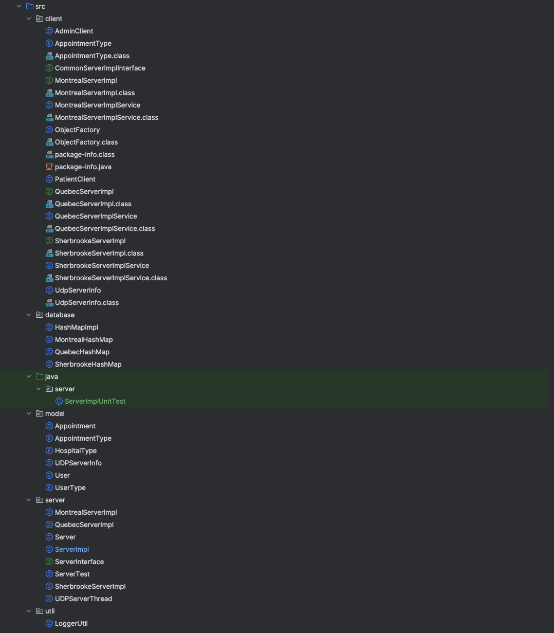 FIG 1 – Project Structure

FIG 2 – UML Diagram of Application

## Steps to Run Application

1. Run the Server class: as that will start all the 3 servers and UDP servers.
2. Run the AdminClient.java and PatientClient.java files
3. Select the operations to perform select (4) to exit.

